Jackson County Fire District 4

Monthly Report: October 2021

Total Number of Incidents for October 2021 104

Average Response time

 | Average Response Time | # of Calls
City limits | 5.64 | 56
Non City/Rural | 10.99 | 40

Monthly Call Volume

Breakdown by Major Incident Type

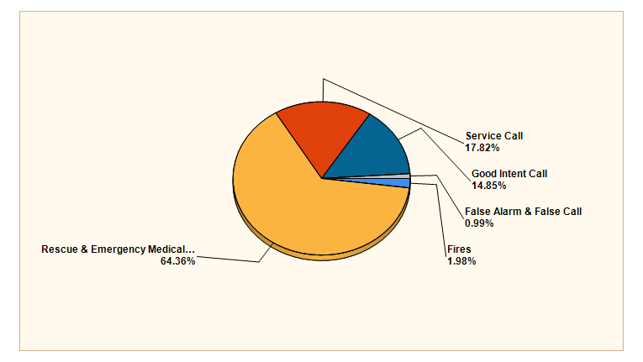

MAJOR INCIDENT TYPE | # INCIDENTS | % of TOTAL
Fires | 2 | 1.98%
Rescue & Emergency Medical Service | 65 | 64.36%
Service Call | 18 | 17.82%
Good Intent Call | 15 | 14.85%
False Alarm & False Call | 1 | 0.99%
TOTAL | 101 | 100%

Detailed Breakdown by Incident Type

Detailed Breakdown by Incident Type
INCIDENT TYPE | # INCIDENTS | % of TOTAL
111 - Building fire | 1 | 0.99%
154 - Dumpster or other outside trash receptacle fire | 1 | 0.99%
311 - Medical assist, assist EMS crew | 7 | 6.93%
321 - EMS call, excluding vehicle accident with injury | 54 | 53.47%
322 - Motor vehicle accident with injuries | 2 | 1.98%
324 - Motor vehicle accident with no injuries. | 1 | 0.99%
363 - Swift water rescue | 1 | 0.99%
542 - Animal rescue | 2 | 1.98%
551 - Assist police or other governmental agency | 1 | 0.99%
552 - Police matter | 2 | 1.98%
553 - Public service | 2 | 1.98%
554 - Assist invalid | 10 | 9.9%
571 - Cover assignment, standby, moveup | 1 | 0.99%
611 - Dispatched & cancelled en route | 13 | 12.87%
622 - No incident found on arrival at dispatch address | 2 | 1.98%
743 - Smoke detector activation, no fire - unintentional | 1 | 0.99%
TOTAL INCIDENTS: | 101 | 100%

Incidents by Day of Week

Incidents by Time of Day

Call History

