Jackson County Fire District 4

Monthly Report: May 2021

Total Number of Incidents for May 2021 123

Average Response time

 | Average Response Time | # of Calls
City limits | 5.22 | 67
Non City/Rural | 12.52 | 43

Monthly Call Volume

Breakdown by Major Incident Type

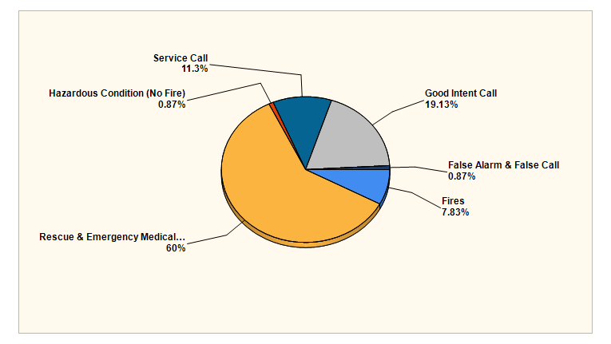

MAJOR INCIDENT TYPE | # INCIDENTS | % of TOTAL
Fires | 9 | 7.83%
Rescue & Emergency Medical Service | 69 | 60%
Hazardous Condition (No Fire) | 1 | 0.87%
Service Call | 13 | 11.3%
Good Intent Call | 22 | 19.13%
False Alarm & False Call | 1 | 0.87%
TOTAL | 115 | 100%

Detailed Breakdown by Incident Type

Detailed Breakdown by Incident Type
INCIDENT TYPE | # INCIDENTS | % of TOTAL
111 - Building fire | 1 | 0.87%
131 - Passenger vehicle fire | 1 | 0.87%
141 - Forest, woods or wildland fire | 2 | 1.74%
143 - Grass fire | 3 | 2.61%
154 - Dumpster or other outside trash receptacle fire | 1 | 0.87%
173 - Cultivated trees or nursery stock fire | 1 | 0.87%
311 - Medical assist, assist EMS crew | 10 | 8.7%
321 - EMS call, excluding vehicle accident with injury | 54 | 46.96%
322 - Motor vehicle accident with injuries | 2 | 1.74%
324 - Motor vehicle accident with no injuries. | 1 | 0.87%
361 - Swimming/recreational water areas rescue | 1 | 0.87%
363 - Swift water rescue | 1 | 0.87%
444 - Power line down | 1 | 0.87%
553 - Public service | 5 | 4.35%
554 - Assist invalid | 8 | 6.96%
611 - Dispatched & cancelled en route | 13 | 11.3%
622 - No incident found on arrival at dispatch address | 7 | 6.09%
631 - Authorized controlled burning | 1 | 0.87%
651 - Smoke scare, odor of smoke | 1 | 0.87%
745 - Alarm system activation, no fire - unintentional | 1 | 0.87%
TOTAL INCIDENTS: | 115 | 100%

Incidents by Day of Week

Incidents by Time of Day

Call History

