Jackson County Fire District 4

Monthly Report: February 2021

Total Number of Incidents for February 2021 68

Average Response time

 | Average Response Time | # of Calls
City limits | 5.55 | 48
Non City/Rural | 7.93 | 19

Monthly Call Volume

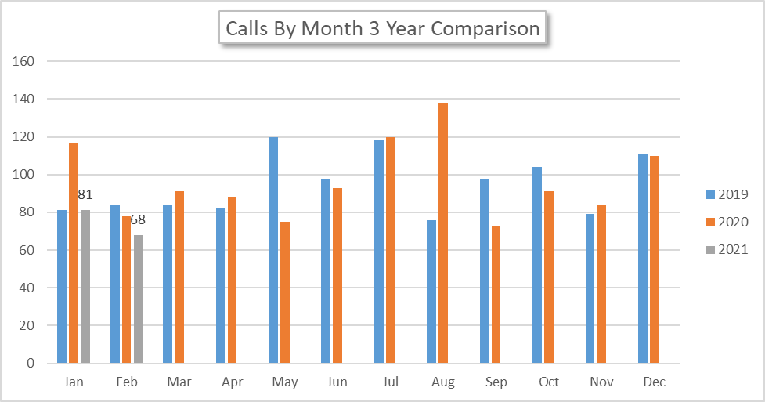

Breakdown by Major Incident Type

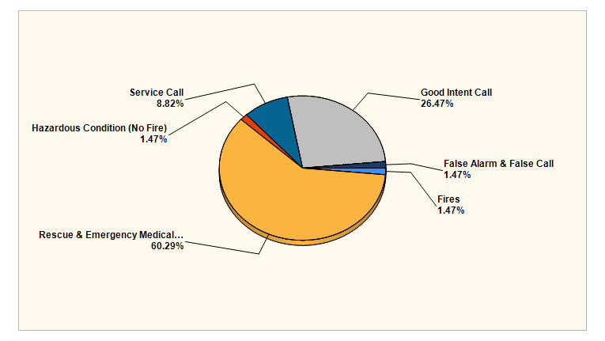

MAJOR INCIDENT TYPE | # INCIDENTS | % of TOTAL
Fires | 1 | 1.47%
Rescue & Emergency Medical Service | 41 | 60.29%
Hazardous Condition (No Fire) | 1 | 1.47%
Service Call | 6 | 8.82%
Good Intent Call | 18 | 26.47%
False Alarm & False Call | 1 | 1.47%
TOTAL | 68 | 100%

Detailed Breakdown by Incident Type

Detailed Breakdown by Incident Type
INCIDENT TYPE | # INCIDENTS | % of TOTAL
151 - Outside rubbish, trash or waste fire | 1 | 1.47%
311 - Medical assist, assist EMS crew | 7 | 10.29%
321 - EMS call, excluding vehicle accident with injury | 31 | 45.59%
322 - Motor vehicle accident with injuries | 1 | 1.47%
324 - Motor vehicle accident with no injuries. | 2 | 2.94%
444 - Power line down | 1 | 1.47%
551 - Assist police or other governmental agency | 1 | 1.47%
554 - Assist invalid | 3 | 4.41%
561 - Unauthorized burning | 2 | 2.94%
611 - Dispatched & cancelled en route | 15 | 22.06%
622 - No incident found on arrival at dispatch address | 2 | 2.94%
631 - Authorized controlled burning | 1 | 1.47%
746 - Carbon monoxide detector activation, no CO | 1 | 1.47%
TOTAL INCIDENTS: | 68 | 100%

Incidents by Day of Week

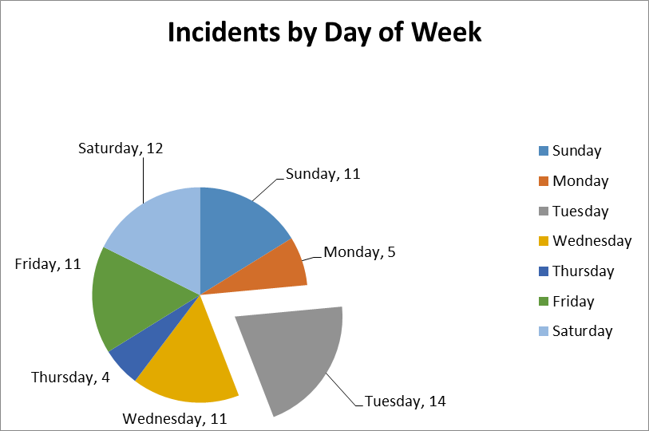

Incidents by Time of Day

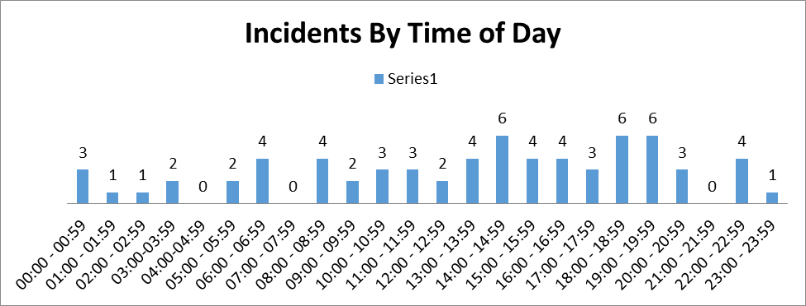

Call History

