Jackson County Fire District 4

Monthly Report: January 2021

Total Number of Incidents for January 2021 80

Average Response time

 | Average Response Time | # of Calls
City limits | 4.92 | 54
Non City/Rural | 8.89 | 25

Monthly Call Volume

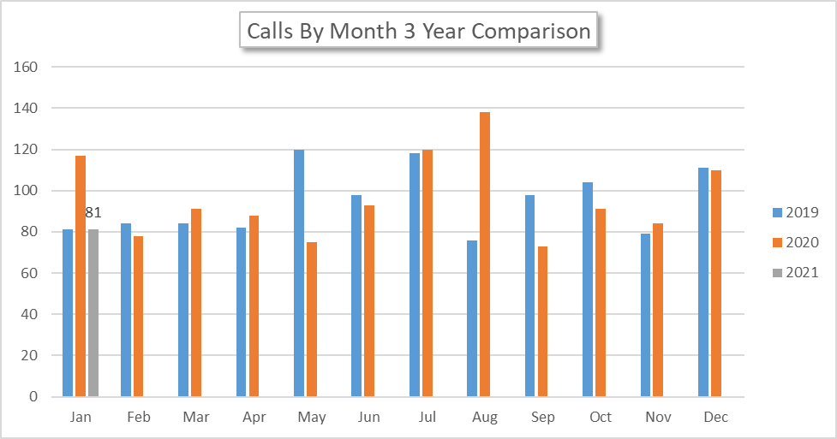

Breakdown by Major Incident Type

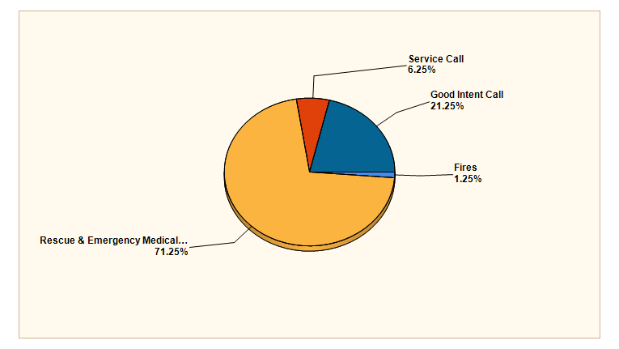

MAJOR INCIDENT TYPE | # INCIDENTS | % of TOTAL
Fires | 1 | 1.25%
Rescue & Emergency Medical Service | 57 | 71.25%
Service Call | 5 | 6.25%
Good Intent Call | 17 | 21.25%
TOTAL | 80 | 100%

Detailed Breakdown by Incident Type

Detailed Breakdown by Incident Type
INCIDENT TYPE | # INCIDENTS | % of TOTAL
111 - Building fire | 1 | 1.25%
311 - Medical assist, assist EMS crew | 9 | 11.25%
321 - EMS call, excluding vehicle accident with injury | 44 | 55%
322 - Motor vehicle accident with injuries | 2 | 2.5%
324 - Motor vehicle accident with no injuries. | 2 | 2.5%
553 - Public service | 1 | 1.25%
554 - Assist invalid | 2 | 2.5%
561 - Unauthorized burning | 2 | 2.5%
611 - Dispatched & cancelled en route | 14 | 17.5%
622 - No incident found on arrival at dispatch address | 2 | 2.5%
631 - Authorized controlled burning | 1 | 1.25%
TOTAL INCIDENTS: | 80 | 100%

Incidents by Day of Week

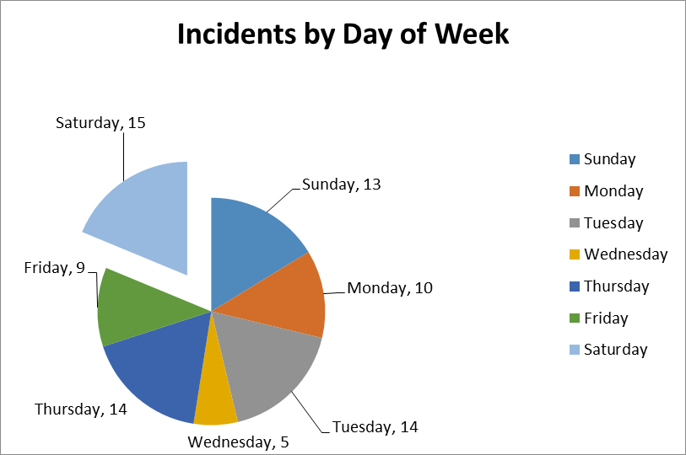

Incidents by Time of Day

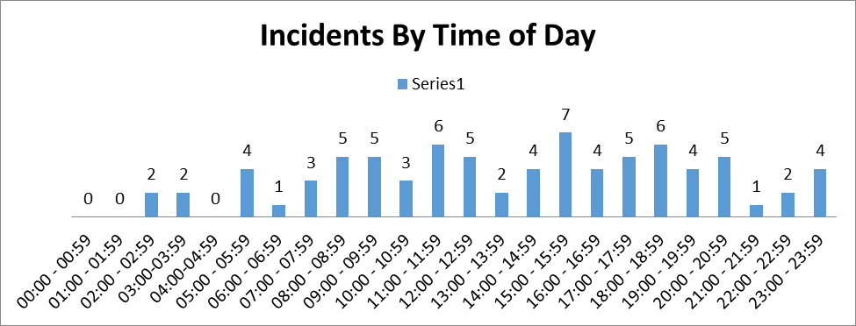

Call History

