Jackson County Fire District 4

Monthly Report: September 2021

Total Number of Incidents for September 2021 95

Average Response time

 | Average Response Time | # of Calls
City limits | 5.68 | 56
Non City/Rural | 12.27 | 33

Monthly Call Volume

Breakdown by Major Incident Type

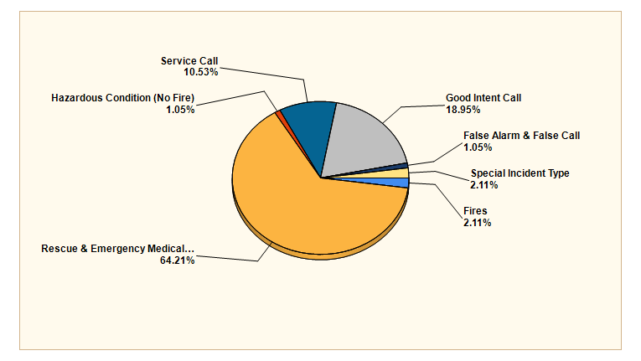

MAJOR INCIDENT TYPE | # INCIDENTS | % of TOTAL
Fires | 2 | 2.11%
Rescue & Emergency Medical Service | 61 | 64.21%
Hazardous Condition (No Fire) | 1 | 1.05%
Service Call | 10 | 10.53%
Good Intent Call | 18 | 18.95%
False Alarm & False Call | 1 | 1.05%
Special Incident Type | 2 | 2.11%
TOTAL | 95 | 100%

Detailed Breakdown by Incident Type

Detailed Breakdown by Incident Type
INCIDENT TYPE | # INCIDENTS | % of TOTAL
131 - Passenger vehicle fire | 1 | 1.05%
143 - Grass fire | 1 | 1.05%
311 - Medical assist, assist EMS crew | 7 | 7.37%
321 - EMS call, excluding vehicle accident with injury | 48 | 50.53%
322 - Motor vehicle accident with injuries | 2 | 2.11%
324 - Motor vehicle accident with no injuries. | 2 | 2.11%
363 - Swift water rescue | 2 | 2.11%
412 - Gas leak (natural gas or LPG) | 1 | 1.05%
551 - Assist police or other governmental agency | 1 | 1.05%
554 - Assist invalid | 6 | 6.32%
561 - Unauthorized burning | 3 | 3.16%
611 - Dispatched & cancelled en route | 15 | 15.79%
622 - No incident found on arrival at dispatch address | 1 | 1.05%
651 - Smoke scare, odor of smoke | 2 | 2.11%
733 - Smoke detector activation due to malfunction | 1 | 1.05%
911 - Citizen complaint | 2 | 2.11%

Incidents by Day of Week

Incidents by Time of Day

Call History

