Jackson County Fire District 4

Monthly Report: March 2022

Total Number of Incidents for March 2022 97

Average Response time
Dispatched and cancelled enroute calls have been excluded

 | Average Response Time | # of Calls
City limits | 4:57 | 50
Non City/Rural | 9:55 | 31

Monthly Call Volume

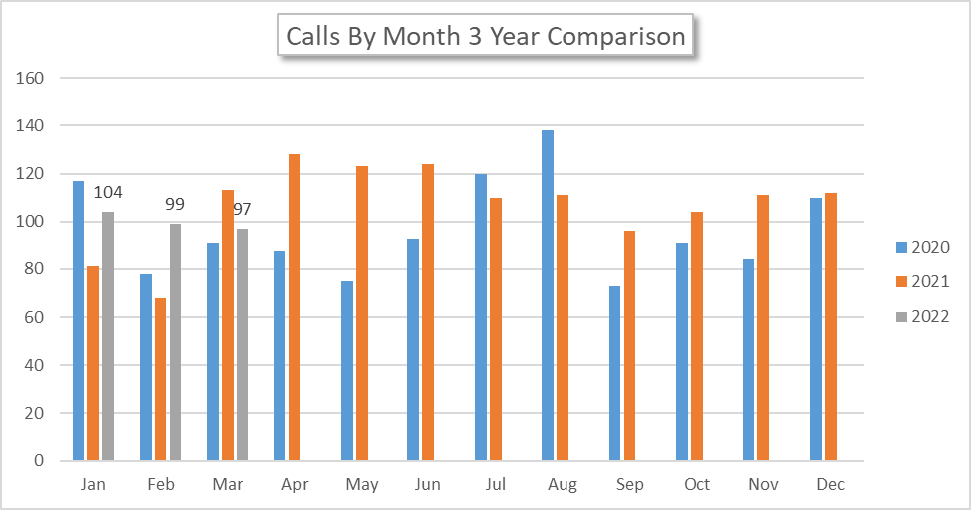

Breakdown by Major Incident Type

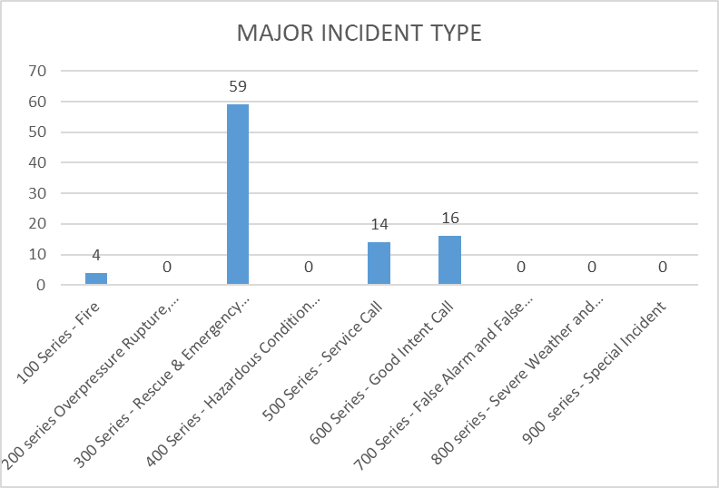

MAJOR INCIDENT TYPE | # INCIDENTS | % of TOTAL
100 Series - Fire | 4 | 4.30%
200 series Overpressure Rupture, Explosion, Overheat No Fire | 0 | 0.00%
300 Series - Rescue & Emergency Medical Service | 59 | 63.44%
400 Series - Hazardous Condition (No Fire) | 0 | 0.00%
500 Series - Service Call | 14 | 15.05%
600 Series - Good Intent Call | 16 | 17.20%
700 Series - False Alarm and False Call | 0 | 0.00%
800 series - Severe Weather and Natural Disaster | 0 | 0.00%
900 series - Special Incident | 0 | 0.00%
TOTAL | 93 | 100%

Call History

