Jackson County Fire District 4

Monthly Report: February 2023

Total Number of Incidents for February 2023 82

Average Response time
Dispatched and cancelled enroute calls have been excluded

 | Average Response Time | # of Calls
City limits | 5:30 | 49
Non City/Rural | 14:12 | 27

Monthly Call Volume

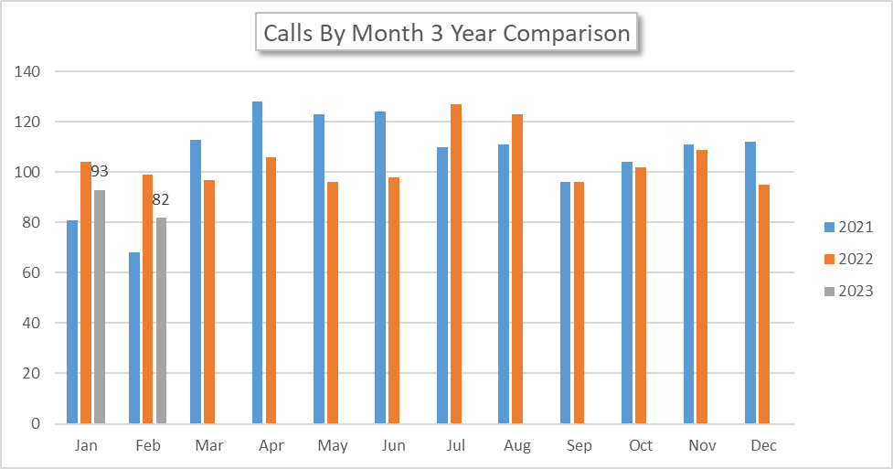

Breakdown by Major Incident Type

MAJOR INCIDENT TYPE | # INCIDENTS | % of TOTAL
100 Series - Fire | 0 | 0.00%
200 series Overpressure Rupture, Explosion, Overheat No Fire | 0 | 0.00%
300 Series - Rescue & Emergency Medical Service | 65 | 79.27%
400 Series - Hazardous Condition (No Fire) | 0 | 0.00%
500 Series - Service Call | 8 | 9.76%
600 Series - Good Intent Call | 9 | 10.98%
700 Series - False Alarm and False Call | 0 | 0.00%
800 series - Severe Weather and Natural Disaster | 0 | 0.00%
900 series - Special Incident | 0 | 0.00%
TOTAL | 82 | 100%

Call History

