Jackson County Fire District 4

Monthly Report: December 2022

Total Number of Incidents for December 2022 95

Average Response time
Dispatched and cancelled enroute calls have been excluded

 | Average Response Time | # of Calls
City limits | 6:06 | 66
Non City/Rural | 11:35 | 29

Monthly Call Volume

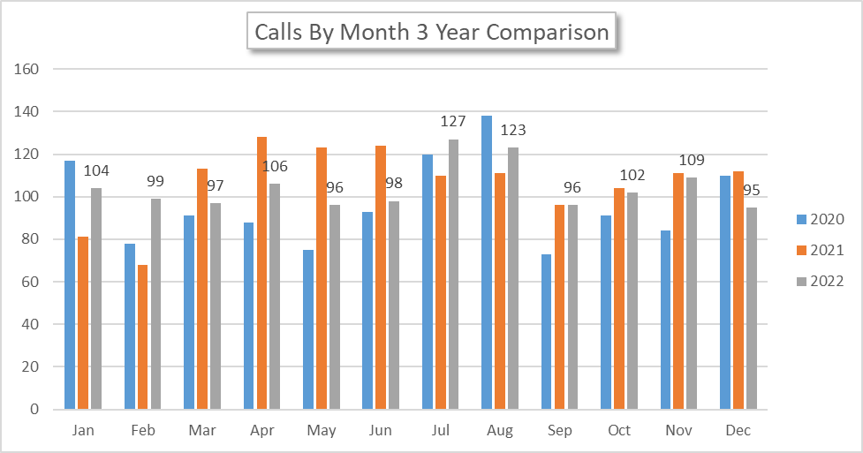

Breakdown by Major Incident Type

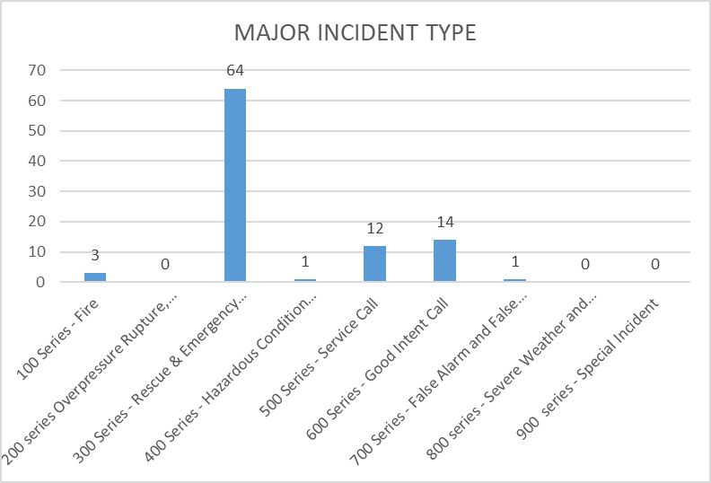

MAJOR INCIDENT TYPE | # INCIDENTS | % of TOTAL
100 Series - Fire | 3 | 3.16%
200 series Overpressure Rupture, Explosion, Overheat No Fire | 0 | 0.00%
300 Series - Rescue & Emergency Medical Service | 64 | 67.37%
400 Series - Hazardous Condition (No Fire) | 1 | 1.05%
500 Series - Service Call | 12 | 12.63%
600 Series - Good Intent Call | 14 | 14.74%
700 Series - False Alarm and False Call | 1 | 1.05%
800 series - Severe Weather and Natural Disaster | 0 | 0.00%
900 series - Special Incident | 0 | 0.00%
TOTAL | 95 | 100%

Call History

