Jackson County Fire District 4

Monthly Report: October 2020

Total Number of Incidents for October 2020 91

Average Response time

 | Average Response Time | # of Calls
City limits | 5.92 | 49
Non City/Rural | 11.61 | 41

Monthly Call Volume

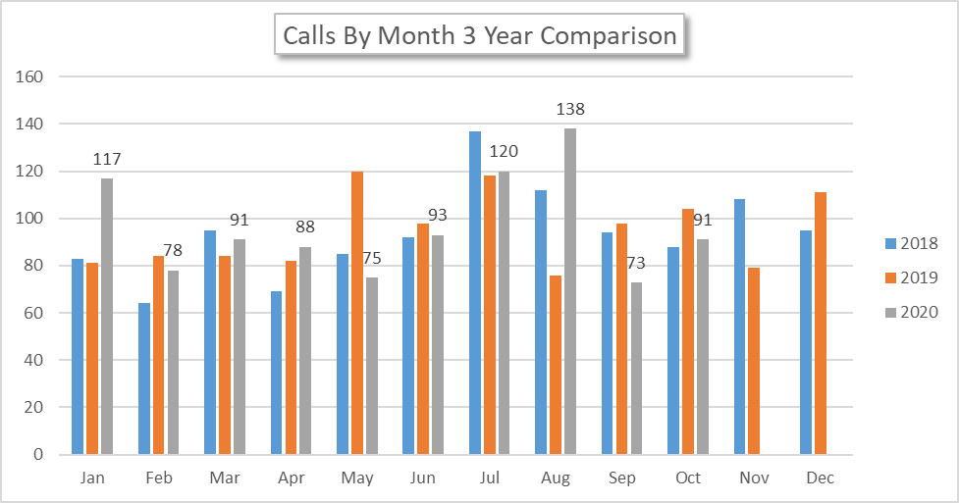

Breakdown by Major Incident Type

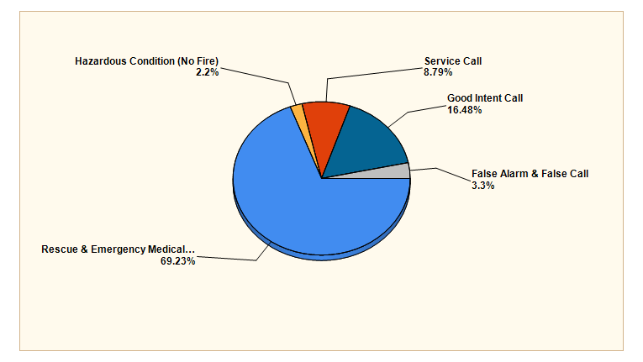

MAJOR INCIDENT TYPE | # INCIDENTS | % of TOTAL
Rescue & Emergency Medical Service | 63 | 69.23%
Hazardous Condition (No Fire) | 2 | 2.2%
Service Call | 8 | 8.79%
Good Intent Call | 15 | 16.48%
False Alarm & False Call | 3 | 3.3%
TOTAL | 91 | 100%

Detailed Breakdown by Incident Type

Detailed Breakdown by Incident Type
INCIDENT TYPE | # INCIDENTS | % of TOTAL
311 - Medical assist, assist EMS crew | 5 | 5.49%
321 - EMS call, excluding vehicle accident with injury | 54 | 59.34%
322 - Motor vehicle accident with injuries | 1 | 1.1%
324 - Motor vehicle accident with no injuries. | 2 | 2.2%
352 - Extrication of victim(s) from vehicle | 1 | 1.1%
441 - Heat from short circuit (wiring), defective/worn | 1 | 1.1%
444 - Power line down | 1 | 1.1%
552 - Police matter | 1 | 1.1%
553 - Public service | 1 | 1.1%
554 - Assist invalid | 5 | 5.49%
561 - Unauthorized burning | 1 | 1.1%
611 - Dispatched & cancelled en route | 11 | 12.09%
622 - No incident found on arrival at dispatch address | 2 | 2.2%
651 - Smoke scare, odor of smoke | 1 | 1.1%
652 - Steam, vapor, fog or dust thought to be smoke | 1 | 1.1%
733 - Smoke detector activation due to malfunction | 1 | 1.1%
743 - Smoke detector activation, no fire - unintentional | 1 | 1.1%
745 - Alarm system activation, no fire - unintentional | 1 | 1.1%
TOTAL INCIDENTS: | 91 | 100%

Incidents by Day of Week

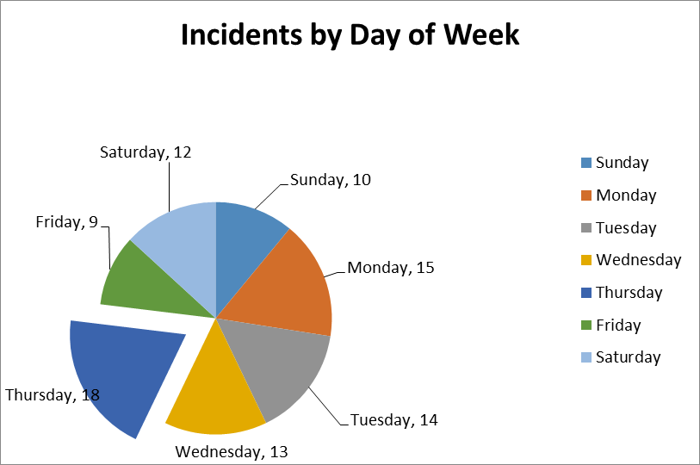
Incidents by Time of Day

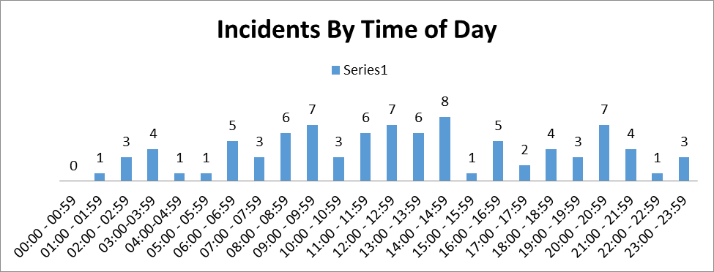

Call History

