Jackson County Fire District 4

Monthly Report: August 2021

Total Number of Incidents for August 2021 111

Average Response time

 | Average Response Time | # of Calls
City limits | 5.36 | 59
Non City/Rural | 13.31 | 46

Monthly Call Volume

Breakdown by Major Incident Type

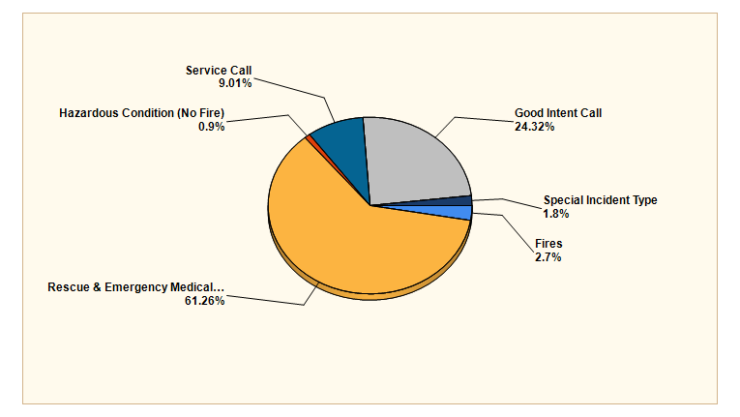

MAJOR INCIDENT TYPE | # INCIDENTS | % of TOTAL
Fires | 3 | 2.7%
Rescue & Emergency Medical Service | 68 | 61.26%
Hazardous Condition (No Fire) | 1 | 0.9%
Service Call | 10 | 9.01%
Good Intent Call | 27 | 24.32%
Special Incident Type | 2 | 1.8%
TOTAL | 111 | 100%

Detailed Breakdown by Incident Type

Detailed Breakdown by Incident Type
INCIDENT TYPE | # INCIDENTS | % of TOTAL
113 - Cooking fire, confined to container | 1 | 0.9%
141 - Forest, woods or wildland fire | 2 | 1.8%
311 - Medical assist, assist EMS crew | 9 | 8.11%
321 - EMS call, excluding vehicle accident with injury | 50 | 45.04%
322 - Motor vehicle accident with injuries | 2 | 1.8%
323 - Motor vehicle/pedestrian accident (MV Ped) | 1 | 0.9%
324 - Motor vehicle accident with no injuries. | 3 | 2.7%
352 - Extrication of victim(s) from vehicle | 1 | 0.9%
361 - Swimming/recreational water areas rescue | 1 | 0.9%
365 - Watercraft rescue | 1 | 0.9%
412 - Gas leak (natural gas or LPG) | 1 | 0.9%
553 - Public service | 3 | 2.7%
554 - Assist invalid | 4 | 3.6%
561 - Unauthorized burning | 2 | 1.8%
571 - Cover assignment, standby, moveup | 1 | 0.9%
611 - Dispatched & cancelled en route | 14 | 12.61%
622 - No incident found on arrival at dispatch address | 4 | 3.6%
651 - Smoke scare, odor of smoke | 9 | 8.11%
911 - Citizen complaint | 2 | 1.8%
TOTAL INCIDENTS: | 111 | 100%

Incidents by Day of Week

Incidents by Time of Day

Call History

